Collateral Web Northwest Dev, 10/20/16

Customer: 3X Farms, Real Property “LT Big Thieltges”

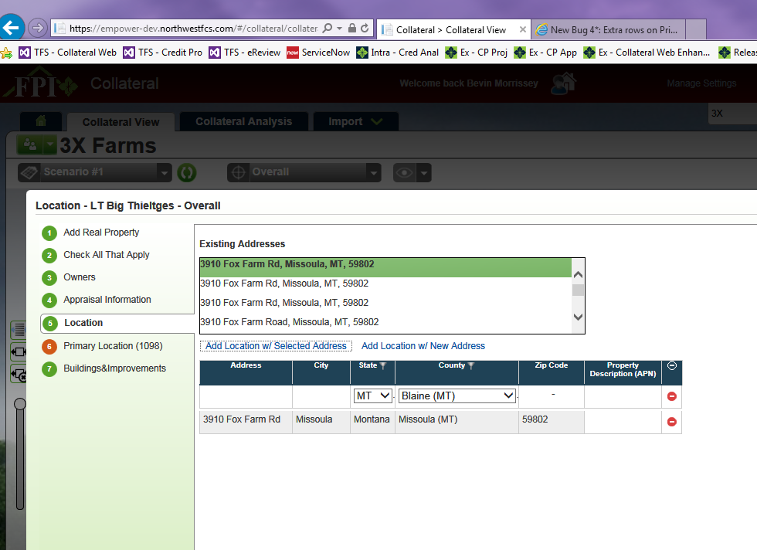

Only have two address rows in the grid on the Location panel…

… but there are multiple similar rows on the Primary Location (1098) panel that don’t exist on the Location panel.

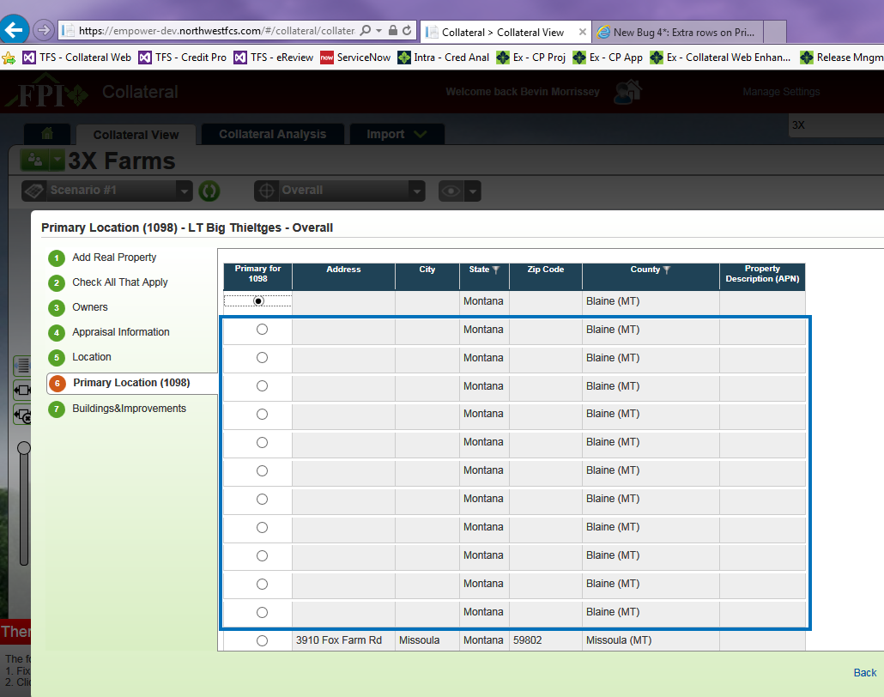

Are these deleted rows? If yes, they shouldn’t be displayed here.